Sarah Archino

52 avenue du General Leclerc

75014 Paris, France

[saraharchino@gmail.com](mailto:saraharchino@gmail.com)

**New York Dada**

Internationally the Dada movement attacked the concept of fine art by rejecting the values of uniqueness, craftsmanship, culture, and artistic genius in favor of chance, multiplicity, non-art materials, and absurdity. The movement known as New York Dada is perhaps a misnomer as Dada activities in New York predate the 1916 formulation of the movement in Zurich. Scholars have dated related activities to 1910, although most chronologies place the movement from 1915 to 1921. Like Zurich Dada, New York Dada is characterised by an irreverent attitude towards traditional forms of art production; however, New York Dada was less an organised ideology than a loosely affiliated celebration of popular culture and anti-authoritarianism. This association of American artists and European exiles centered around the New York apartment of Walter and Louise Arensberg. The Arensberg “salon” counted among its frequent visitors Marcel Duchamp and Francis Picabia. These two artists, along with the American, Man Ray and Elsa von Freytag-Lovinghoven were the most active Dadaists in New York. Although no single style emerged, there was a common interest in the machine aesthetic, as seen in the mechanomorphic works of Picabia, the assemblages and photographs of Man Ray, and (most notoriously) the readymades of Duchamp.

The artists associated with New York Dada resisted identification as a group. With no manifestos, no statements of ideology and no group exhibitions, it is difficult to locate the movement chronologically. Only in 1921, months before leaving New York for Paris, did Man Ray and Duchamp edit the single issue of *New York Dada*, which included an "authorisation" from the Zurich Dadaist Tristan Tzara. Perhaps the most significant challenge to the tradition of fine art were Duchamp’s readymades, mass-produced objects which he purchased and exhibited, with little or no alteration, and declared to be art. Although Duchamp had begun the practice in France, it was in New York that he called these works “readymades” and exhibited them outside of his studio. Claiming they were chosen without regard to aesthetic value, Duchamp paired these items with punning titles, such as a snow shovel titled, *In Advance of the Broken Arm* (1915). Most infamously, he submitted *Fountain* (1917) to the jury-less Society of Independent Artists Exhibition in 1917, under the pseudonym Richard Mutt. When the work, which consisted of a urinal rotated ninety-degrees and signed by R. Mutt, was rejected despite the society’s founding principle of inclusion, Duchamp published the second issue of the art journal *The Blind Man* as a defense. Without revealing his identity as its author, Duchamp and his colleagues argued that the choice of the urinal had “created a new thought for that object” and concluded that “The only works of art America has given are her plumbing and her bridges.”

**References and Further Reading**

Dickerman, L (ed.) (2006) Dada: Zurich, Berlin, Hannover, Cologne, New York, Paris, Washington, DC: National Gallery of Art.

Gaughan, M. (ed.) (2003) Dada New York: New World for Old, New Haven: Yale University Press.

Leavens, B. (1983) From 291 to Zurich: The Birth of Dada, Ann Arbor: University of Michigan Press.

Sawelson-Gorse, N. (ed.) (1998) Women in Dada: Essays on Sex, Gender, and Identity, Cambridge: The MIT Press.

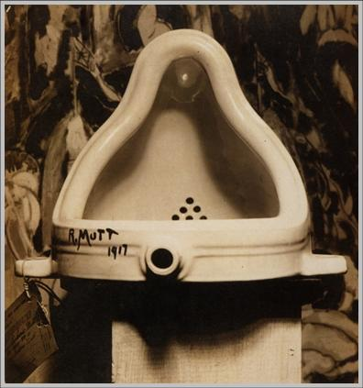

**Image included: Marcel Duchamp, Fountain, 1917, photograph by Alfred Stieglitz. Gelatin silver print. 9 ¼ x 7” Seccession Marcel Duchamp, Villiers-sous-Grez, France**